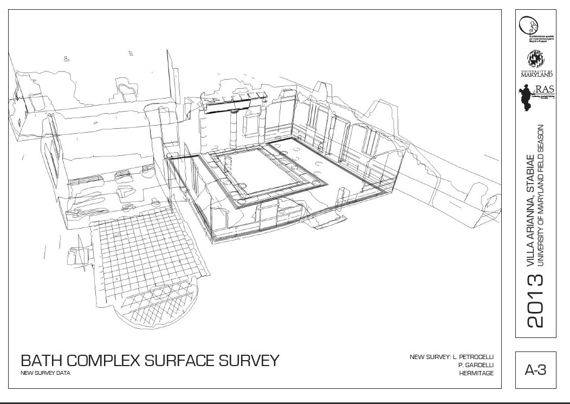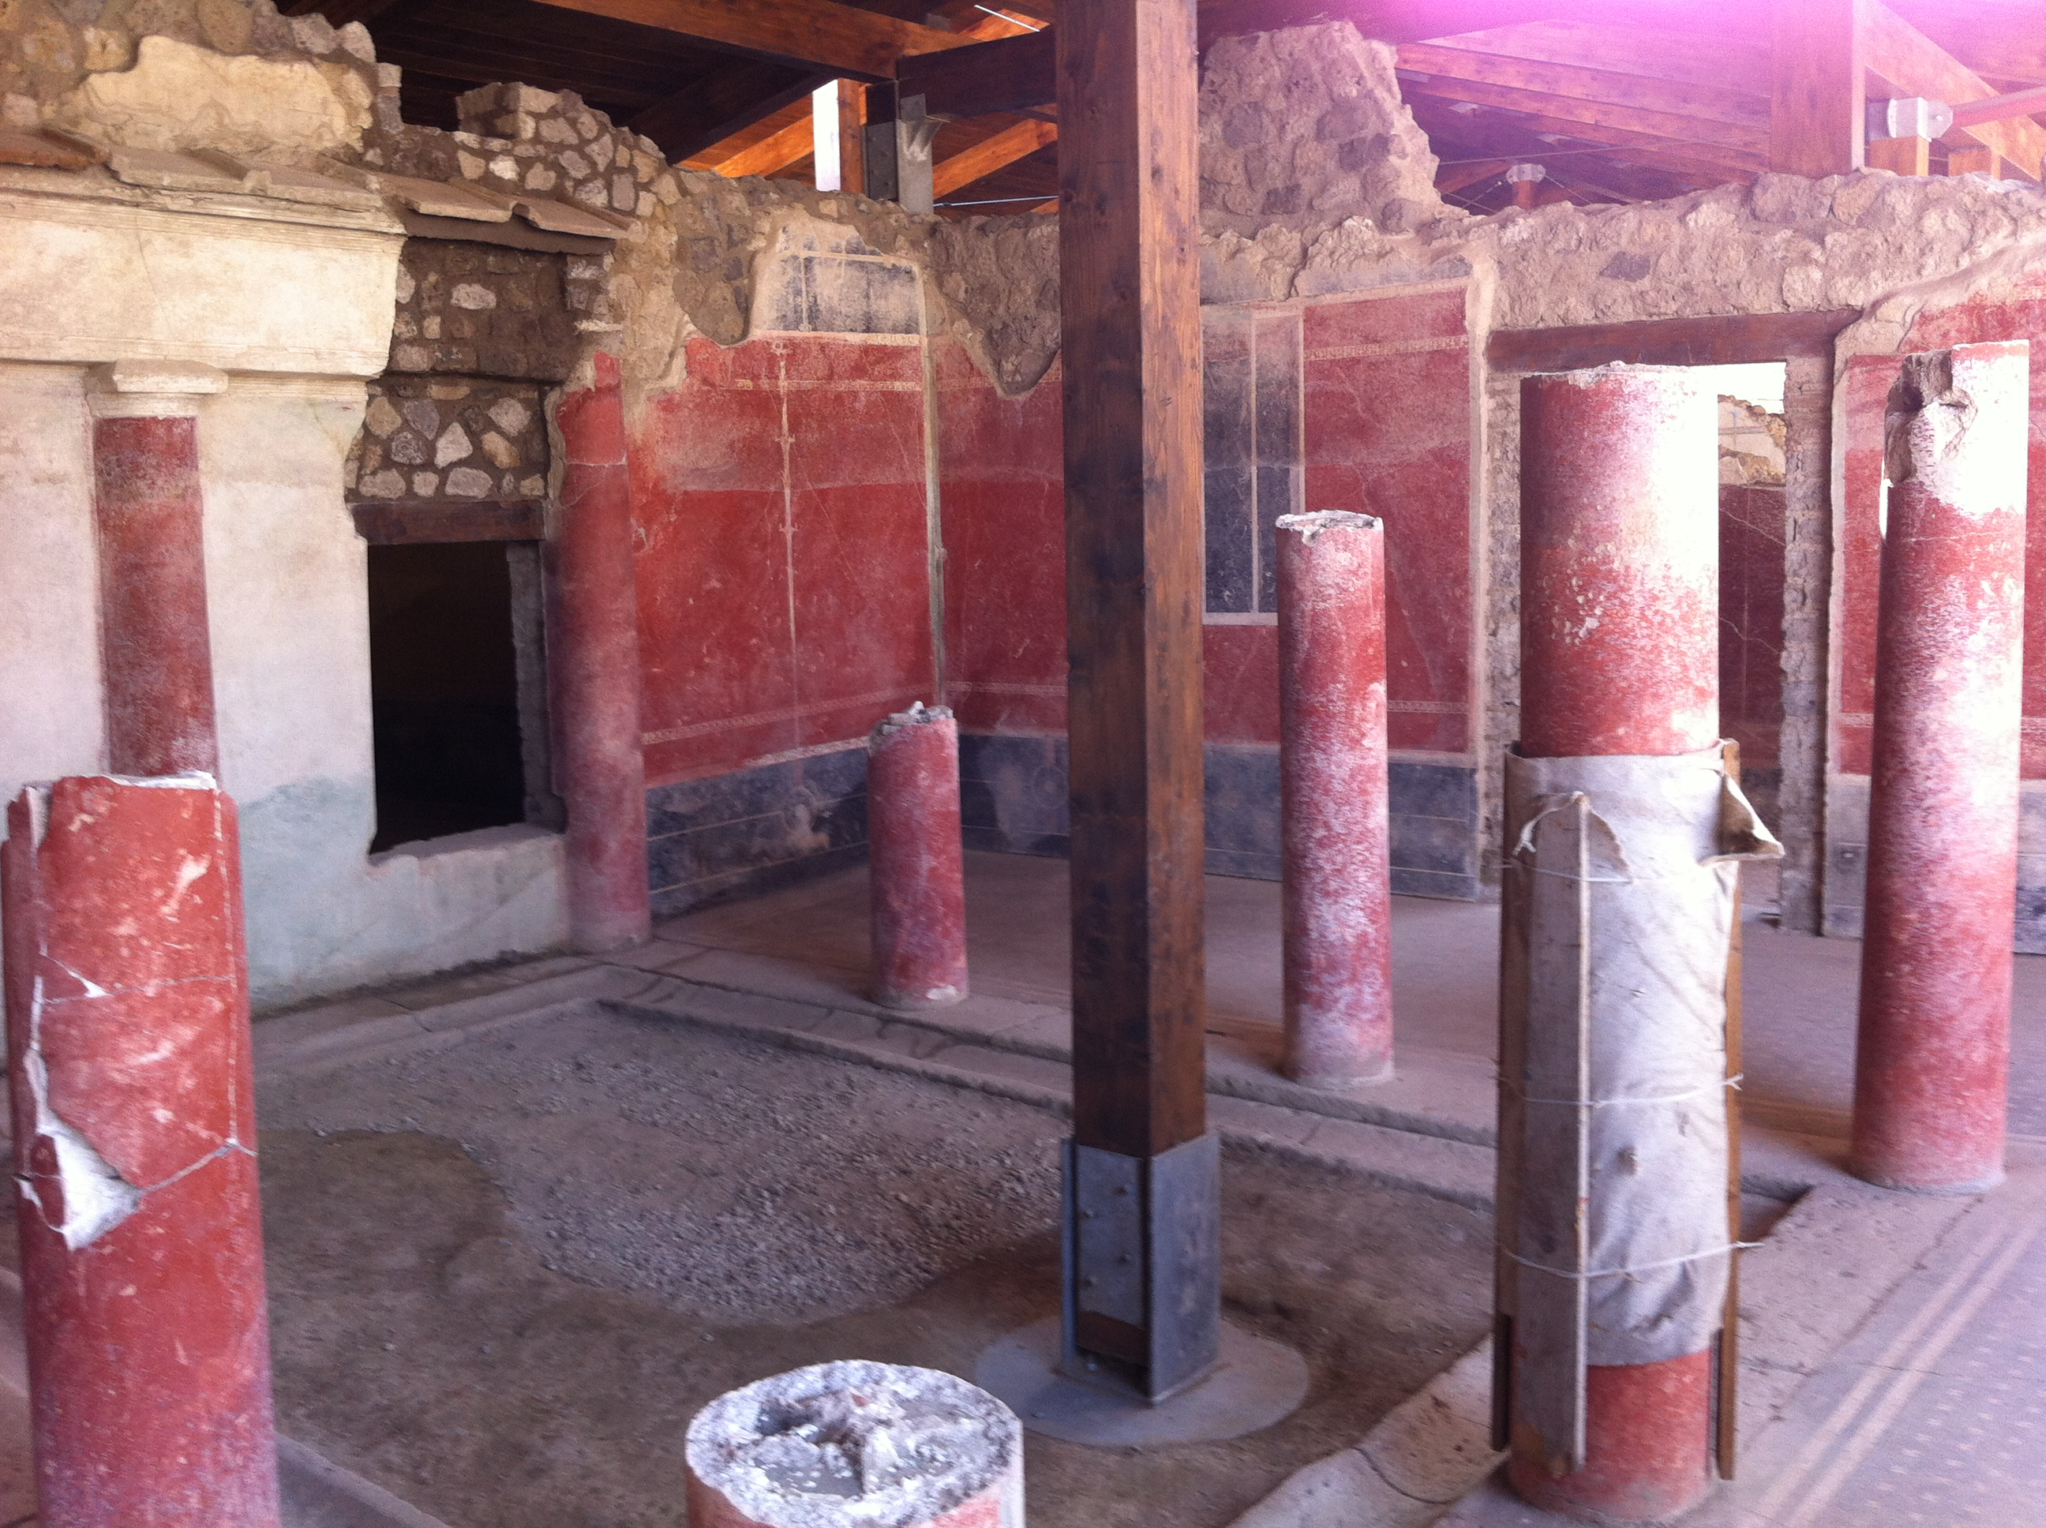
Combined Field School and Field Season in Architectural Recording for Archaeology
Field School: June 22- July 10, 2015
(arrival Sunday, June 21, departure, Saturday, July 11, 2015)
A three-credit course with transfer credit offered by the University of Maryland School of Architecture, Planning and Preservation, focusing teaching basic skills in digital architectural field recording for archaeology, and doing active fieldwork at the ancient seaside villas of STABIAE in Castellammare di Stabia, Italy.

Faculty: Profs. Thomas Noble Howe, Robert Lindley Vann, Ian Sutherland. All three are active archaeologists on the Stabiae archaeological site.
Docents/TA’s: architects Luke Petrocelli, and docents from students/alumni of the UMd School of Architecture.
Contacts: vann@umd.edu, howet@southwestern.edu,

This is a three-week course digital recording of upstanding Roman architecture for archaeology. The aim is to train students in particular type of architectural recording for archaeology which combines techniques of hand drawing, photography, digital three-dimensional drawing with a surveying instrument (reflectorless total station theodolite) and CAD post-production preparation of final drawings. The goal is train students so that within one to two weeks they will understand the whole process and be able to participate productively in a fully active architectural recording team on the archaeological of the large Roman villas of Stabiae. At the conclusion of this course a successful student should be capable of being a valuable member of many types of architectural recording teams or assisting in the production of “as-built” drawings for architects. The course also will feature some introduction to survey control and LiDAR technology.

Requirements: open to undergraduates and graduates. Some preference will be given to students who have had some experience of architecture, or have an ability to draw, particularly freehand architectural drawings, but also for those students in fields such as archaeology, classics and art history. Knowledge of trigonometry or CAD is not necessary, although students should be prepared to bring a personal computer equipped with a current version of AutoCAD, which can be downloaded free for anyone with a .edu email address, and Adobe Illustrator.

The course will be housed at the Vesuvian Institute of the Restoring Ancient Stabiae Foundation in Castellammare (near Pompeii) and will focus on the archaeological site of the Roman villas of Stabiae. Program will incorporate visits and general introduction to neighboring sites of Pompeii, Herculaneum and Oplontis.

Stabiae, 4 km from Pompeii, is the largest concentration of well-preserved large seaside Roman villas in the entire Mediterranean.

Accommodation will be in the modern Vesuvian Institute (pictured above) with double occupancy, private bath in every room, full board with a local Italian kitchen.

Program cost: $3300, tuition for 3 course credits from University of Maryland, and full room and board at the Vesuvian Institute of the Restoring Ancient Stabiae Foundation. Not including air transportation.

